Arduino Lesson 25
LED Dot Matrix Display – Scrolling Message

- Intro
There are many different ways to drive LEDs. Using shift registers is one way and they have their advantages. However, there are lots of ICs available that are specifically designed to drive LED displays and make life a lot easier for you. One of the most popular LED Driver ICs in the Arduino community is the MAX7219 serial interfaced, 8-digit LED Display Driver chips made by Maxim. These chips are designed to control 7-segment numeric LED displays of up to 8 digits, bar graph displays, or 88 LED dot matrix displays, which is what you will be using them for. The Arduino IDE comes with a library called Matrix plus some example code that was specifically written for the MAX7219 chips. Using this library will make using these chips a breeze. However, in this project you are not going to use any external libraries. Instead, you are going to do things the hard way and write every piece of code yourself. That way, you will learn exactly how the MAX7219 chip works, and you can transfer these skills to utilizing any other LED driver chip you wish.

- Parts Required
You will need a MAX7219 LED Driver IC. Alternatively, you can use an Austria Microsystems AS1107, which is pretty much identical to the MAX7219 and will work with no changes to your code or circuit. The 88 dot matrix display needs to be of the Common Cathode variety this time as the MAX chip will not work with a Common Anode display.

- MAX7219 (or AS1107)
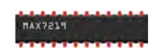
- Current Limiting Resistor
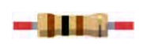
- 8x8 Dot Matrix Display (C-)
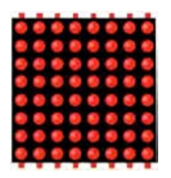

- Connect It Up
Examine the diagram carefully in Figure 7-4. Make sure your Arduino is powered off while connecting the wires. The wiring from the MAX7219 to the dot matrix display in Figure 7-4 is set up for the display unit I used for creating this project. The pins on your display may differ. This isn’t relevant, just wire up the pins coming out of the MAX7219 to the appropriate column and row pins on your display (see Table 7-3 for the pinouts). Reading horizontally will show which two devices are connected and to what pins. On the display, the columns are the cathodes and the rows are the anodes. On my display, I found Row 1 was at the bottom and Row 8 the top. You may need to reverse the order on your own display if you find your letters are upside down or back to front. Connect the 5V from the Arduino to the positive rail of the breadboard and the ground to the ground rail.
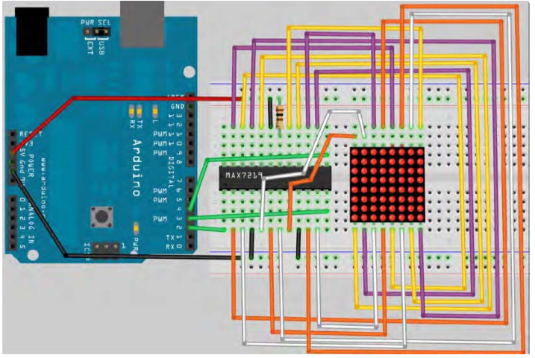
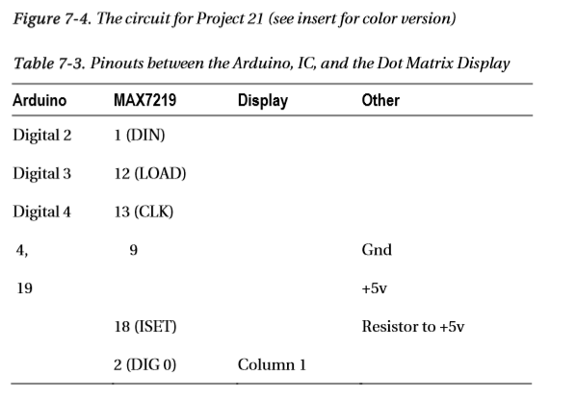
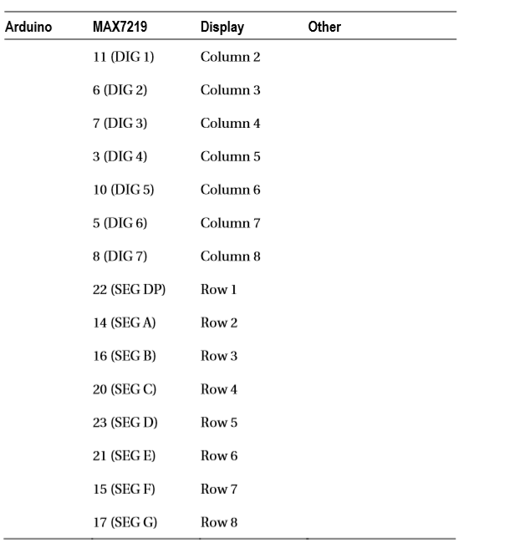
- Enter the code

#include <avr/pgmspace.h> #include <TimerOne.h>
int DataPin = 2; // Pin 1 on MAX int LoadPin = 3; // Pin 12 on MAX
int ClockPin = 4; // Pin 13 on MAX byte buffer[8];
static byte font[][8] PROGMEM = { // The printable ASCII characters only (32-126) {B00000000, B00000000, B00000000, B00000000, B00000000, B00000000, B00000000, B00000000}, {B00000100, B00000100, B00000100, B00000100, B00000100, B00000100, B00000000, B00000100}, {B00001010, B00001010, B00001010, B00000000, B00000000, B00000000, B00000000, B00000000}, {B00000000, B00001010, B00011111, B00001010, B00011111, B00001010, B00011111, B00001010}, {B00000111, B00001100, B00010100, B00001100, B00000110, B00000101, B00000110, B00011100}, {B00011001, B00011010, B00000010, B00000100, B00000100, B00001000, B00001011, B00010011}, {B00000110, B00001010, B00010010, B00010100, B00001001, B00010110, B00010110, B00001001}, {B00000100, B00000100, B00000100, B00000000, B00000000, B00000000, B00000000, B00000000}, {B00000010, B00000100, B00001000, B00001000, B00001000, B00001000, B00000100, B00000010}, {B00001000, B00000100, B00000010, B00000010, B00000010, B00000010, B00000100, B00001000}, {B00010101, B00001110, B00011111, B00001110, B00010101, B00000000, B00000000, B00000000}, {B00000000, B00000000, B00000100, B00000100, B00011111, B00000100, B00000100, B00000000}, {B00000000, B00000000, B00000000, B00000000, B00000000, B00000110, B00000100, B00001000}, {B00000000, B00000000, B00000000, B00000000, B00001110, B00000000, B00000000, B00000000}, {B00000000, B00000000, B00000000, B00000000, B00000000, B00000000, B00000000, B00000100}, {B00000001, B00000010, B00000010, B00000100, B00000100, B00001000, B00001000, B00010000}, {B00001110, B00010001, B00010011, B00010001, B00010101, B00010001, B00011001, B00001110}, {B00000100, B00001100, B00010100, B00000100, B00000100, B00000100, B00000100, B00011111}, {B00001110, B00010001, B00010001, B00000010, B00000100, B00001000, B00010000, B00011111}, {B00001110, B00010001, B00000001, B00001110, B00000001, B00000001, B00010001, B00001110}, {B00010000, B00010000, B00010100, B00010100, B00011111, B00000100, B00000100, B00000100}, {B00011111, B00010000, B00010000, B00011110, B00000001, B00000001, B00000001, B00011110}, {B00000111, B00001000, B00010000, B00011110, B00010001, B00010001, B00010001, B00001110}, {B00011111, B00000001, B00000001, B00000001, B00000010, B00000100, B00001000, B00010000}, {B00001110, B00010001, B00010001, B00001110, B00010001, B00010001, B00010001, B00001110}, {B00001110, B00010001, B00010001, B00001111, B00000001, B00000001, B00000001, B00000001}, {B00000000, B00000100, B00000100, B00000000, B00000000, B00000100, B00000100, B00000000}, {B00000000, B00000100, B00000100, B00000000, B00000000, B00000100, B00000100, B00001000}, {B00000001, B00000010, B00000100, B00001000, B00001000, B00000100, B00000010, B00000001}, {B00000000, B00000000, B00000000, B00011110, B00000000, B00011110, B00000000, B00000000}, {B00010000, B00001000, B00000100, B00000010, B00000010, B00000100, B00001000, B00010000}, {B00001110, B00010001, B00010001, B00000010, B00000100, B00000100, B00000000, B00000100}, {B00001110, B00010001, B00010001, B00010101, B00010101, B00010001, B00010001, B00011110}, {B00001110, B00010001, B00010001, B00010001, B00011111, B00010001, B00010001, B00010001}, {B00011110, B00010001, B00010001, B00011110, B00010001, B00010001, B00010001, B00011110}, {B00000111, B00001000, B00010000, B00010000, B00010000, B00010000, B00001000, B00000111}, {B00011100, B00010010, B00010001, B00010001, B00010001, B00010001, B00010010, B00011100}, {B00011111, B00010000, B00010000, B00011110, B00010000, B00010000, B00010000, B00011111}, {B00011111, B00010000, B00010000, B00011110, B00010000, B00010000, B00010000, B00010000}, {B00001110, B00010001, B00010000, B00010000, B00010111, B00010001, B00010001, B00001110}, {B00010001, B00010001, B00010001, B00011111, B00010001, B00010001, B00010001, B00010001}, {B00011111, B00000100, B00000100, B00000100, B00000100, B00000100, B00000100, B00011111}, {B00011111, B00000100, B00000100, B00000100, B00000100, B00000100, B00010100, B00001000}, {B00010001, B00010010, B00010100, B00011000, B00010100, B00010010, B00010001, B00010001}, {B00010000, B00010000, B00010000, B00010000, B00010000, B00010000, B00010000, B00011111}, {B00010001, B00011011, B00011111, B00010101, B00010001, B00010001, B00010001, B00010001}, {B00010001, B00011001, B00011001, B00010101, B00010101, B00010011, B00010011, B00010001},

{B00001110, B00010001, B00010001, B00010001, B00010001, B00010001, B00010001, B00001110}, {B00011110, B00010001, B00010001, B00011110, B00010000, B00010000, B00010000, B00010000}, {B00001110, B00010001, B00010001, B00010001, B00010001, B00010101, B00010011, B00001111}, {B00011110, B00010001, B00010001, B00011110, B00010100, B00010010, B00010001, B00010001}, {B00001110, B00010001, B00010000, B00001000, B00000110, B00000001, B00010001, B00001110}, {B00011111, B00000100, B00000100, B00000100, B00000100, B00000100, B00000100, B00000100}, {B00010001, B00010001, B00010001, B00010001, B00010001, B00010001, B00010001, B00001110}, {B00010001, B00010001, B00010001, B00010001, B00010001, B00010001, B00001010, B00000100}, {B00010001, B00010001, B00010001, B00010001, B00010001, B00010101, B00010101, B00001010}, {B00010001, B00010001, B00001010, B00000100, B00000100, B00001010, B00010001, B00010001}, {B00010001, B00010001, B00001010, B00000100, B00000100, B00000100, B00000100, B00000100}, {B00011111, B00000001, B00000010, B00000100, B00001000, B00010000, B00010000, B00011111}, {B00001110, B00001000, B00001000, B00001000, B00001000, B00001000, B00001000, B00001110}, {B00010000, B00001000, B00001000, B00000100, B00000100, B00000010, B00000010, B00000001}, {B00001110, B00000010, B00000010, B00000010, B00000010, B00000010, B00000010, B00001110}, {B00000100, B00001010, B00010001, B00000000, B00000000, B00000000, B00000000, B00000000}, {B00000000, B00000000, B00000000, B00000000, B00000000, B00000000, B00000000, B00011111}, {B00001000, B00000100, B00000000, B00000000, B00000000, B00000000, B00000000, B00000000}, {B00000000, B00000000, B00000000, B00001110, B00010010, B00010010, B00010010, B00001111}, {B00000000, B00010000, B00010000, B00010000, B00011100, B00010010, B00010010, B00011100}, {B00000000, B00000000, B00000000, B00001110, B00010000, B00010000, B00010000, B00001110}, {B00000000, B00000001, B00000001, B00000001, B00000111, B00001001, B00001001, B00000111}, {B00000000, B00000000, B00000000, B00011100, B00010010, B00011110, B00010000, B00001110}, {B00000000, B00000011, B00000100, B00000100, B00000110, B00000100, B00000100, B00000100}, {B00000000, B00001110, B00001010, B00001010, B00001110, B00000010, B00000010, B00001100}, {B00000000, B00010000, B00010000, B00010000, B00011100, B00010010, B00010010, B00010010}, {B00000000, B00000000, B00000100, B00000000, B00000100, B00000100, B00000100, B00000100}, {B00000000, B00000010, B00000000, B00000010, B00000010, B00000010, B00000010, B00001100}, {B00000000, B00010000, B00010000, B00010100, B00011000, B00011000, B00010100, B00010000}, {B00000000, B00010000, B00010000, B00010000, B00010000, B00010000, B00010000, B00001100}, {B00000000, B00000000, B00000000, B00001010, B00010101, B00010001, B00010001, B00010001}, {B00000000, B00000000, B00000000, B00010100, B00011010, B00010010, B00010010, B00010010}, {B00000000, B00000000, B00000000, B00001100, B00010010, B00010010, B00010010, B00001100}, {B00000000, B00011100, B00010010, B00010010, B00011100, B00010000, B00010000, B00010000}, {B00000000, B00001110, B00010010, B00010010, B00001110, B00000010, B00000010, B00000001}, {B00000000, B00000000, B00000000, B00001010, B00001100, B00001000, B00001000, B00001000}, {B00000000, B00000000, B00001110, B00010000, B00001000, B00000100, B00000010, B00011110}, {B00000000, B00010000, B00010000, B00011100, B00010000, B00010000, B00010000, B00001100}, {B00000000, B00000000, B00000000, B00010010, B00010010, B00010010, B00010010, B00001100}, {B00000000, B00000000, B00000000, B00010001, B00010001, B00010001, B00001010, B00000100}, {B00000000, B00000000, B00000000, B00010001, B00010001, B00010001, B00010101, B00001010}, {B00000000, B00000000, B00000000, B00010001, B00001010, B00000100, B00001010, B00010001}, {B00000000, B00000000, B00010001, B00001010, B00000100, B00001000, B00001000, B00010000}, {B00000000, B00000000, B00000000, B00011111, B00000010, B00000100, B00001000, B00011111}, {B00000010, B00000100, B00000100, B00000100, B00001000, B00000100, B00000100, B00000010}, {B00000100, B00000100, B00000100, B00000100, B00000100, B00000100, B00000100, B00000100}, {B00001000, B00000100, B00000100, B00000100, B00000010, B00000100, B00000100, B00001000}, {B00000000, B00000000, B00000000, B00001010, B00011110, B00010100, B00000000, B00000000} };

void clearDisplay() {
for (byte x=0; x<8; x++) {
buffer[x] = B00000000; }
screenUpdate(); }
void initMAX7219() {
pinMode(DataPin, OUTPUT);
pinMode(LoadPin, OUTPUT);
pinMode(ClockPin, OUTPUT);
clearDisplay();
writeData(B00001011, B00000111); // scan limit set to 0:7
writeData(B00001001, B00000000); // decode mode off
writeData(B00001100, B00000001); // Set shutdown register to normal operation
intensity(15); // Values 0 to 15 only (4 bit) }
void intensity(int intensity) {
writeData(B00001010, intensity); //B0001010 is the Intensity Register }
void writeData(byte MSB, byte LSB) {
byte mask;
digitalWrite(LoadPin, LOW); // set loadpin ready to receive data
// Send out MSB for (mask = B10000000; mask>0; mask >>= 1) { //iterate through bit mask
digitalWrite(ClockPin, LOW);
if (MSB & mask){ // if bitwise AND resolves to true digitalWrite(DataPin,HIGH); // send 1 }
else{ //if bitwise and resolves to false
digitalWrite(DataPin,LOW); // send 0 } digitalWrite(ClockPin, HIGH); // clock high, data gets input } // send out LSB for data
for (mask = B10000000; mask>0; mask >>= 1) { //iterate through bit mask digitalWrite(ClockPin, LOW);
if (LSB & mask){ // if bitwise AND resolves to true digitalWrite(DataPin,HIGH); // send 1 }
else{ //if bitwise and resolves to false
digitalWrite(DataPin,LOW); // send 0 } digitalWrite(ClockPin, HIGH); // clock high, data gets input } digitalWrite(LoadPin, HIGH); // latch the data
digitalWrite(ClockPin, LOW); }

void scroll(char myString[], int speed) {
byte firstChrRow, secondChrRow;
byte ledOutput;
byte chrPointer = 0; // Initialise the string position pointer
byte Char1, Char2; // the two characters that will be displayed
byte scrollBit = 0;
byte strLength = 0;
unsigned long time;
unsigned long counter;
// Increment count till we reach the string
while (myString[strLength]) {strLength++;}

counter = millis();

while (chrPointer < (strLength-1)) {
time = millis();
if (time > (counter + speed)) {
Char1 = myString[chrPointer];
Char2 = myString[chrPointer+1];
for (byte y= 0; y<8; y++)
{
firstChrRow = pgm_read_byte(&font[Char1 - 32][y]); secondChrRow = (pgm_read_byte(&font[Char2 - 32][y])) << 1; ledOutput = (firstChrRow << scrollBit) | (secondChrRow >> (8 - scrollBit) ); buffer[y] = ledOutput;
}
scrollBit++;
if (scrollBit > 6) {
scrollBit = 0;
chrPointer++;
}
counter = millis();
} } }
void screenUpdate() {
for (byte row = 0; row < 8; row++)
{
writeData(row+1, buffer[row]);
} }
void setup() {
initMAX7219();
Timer1.initialize(10000); // initialize timer1 and set interrupt period
Timer1.attachInterrupt(screenUpdate); }
void loop() { clearDisplay();
scroll(" BEGINNING ARDUINO ", 45);
scroll(" Lesson 25-LED Displays ", 45);
scroll(" HELLO WORLD!!! :) ", 45); }

When you upload the code, you will see a message scroll across the display.

